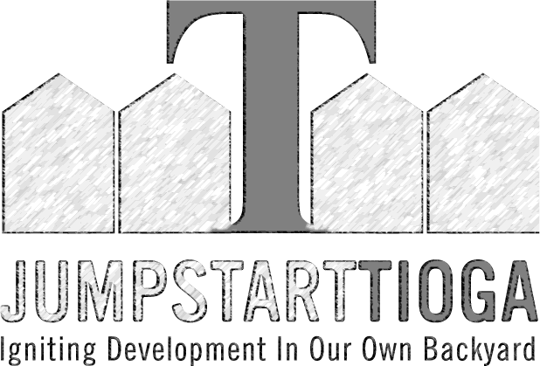
TRAINING PROGRAM SURVEY

Please take note of the following information:
- There is no application fee for the JUMPSTART TIOGA program. You may apply to the program for free. However, once selected as a participant we require a $100.00 Participation Fee. The fees cover class materials, resources and programs costs. Your $100 will be due once you accept the invitation to attend the Jumpstart Training Program.
- Selected applicants will be notified using the contact information listed below. Please write legibly and make sure the information is accurate.

PERSONAL INFORMATION
First Name_____________________________________________________ Last Name_______________________________________________
Street Address____________________________________________________________________________________________________________
Address Line 2____________________________________________________________________________________________________________
City______________________________________ State / Province / Region______________ Zip Code________________
Home Phone Number _______________________________________ Cell Phone Number _______________________________________
Email ___________________________________________________________________________________________________________________
Circle your preferred method of contact: CALL TEXT EMAIL
REAL ESTATE EXPERIENCE
- Number of units currently owned____________________________________________________________________________________
- Describe your interest in real estate development/investing. ______________________________________________________________
________________________________________________________________________________________________________________________________________________________________________________________________________________________________________________
- Describe your prior real estate experience, if any. _______________________________________________________________________
________________________________________________________________________________________________________________________________________________________________________________________________________________________________________________
- What do you hope to gain through participating in the Jumpstart Tioga training program? ______________________________________
________________________________________________________________________________________________________________________________________________________________________________________________________________________________________________
- Describe your community interest in, or connection to Tioga. _________________________________________
________________________________________________________________________________________________________________________________________________________________________________________________________________________________________________
- What is your 5-year real estate investment goal? _______________________________________________________________________
________________________________________________________________________________________________________________________________________________________________________________________________________________________________________________
- How will you participate with Jumpstart Tioga? As a:
Training Program Participant or Program Mentor(experience required)

- Have you attended a Jumpstart Training Program elsewhere?
Yes No
If yes, where? _________________________________________________________________________
- Are you on a wait list with any other Jumpstart program?
Yes No
If yes, where? _________________________________________________________________________
- Are you current working on any real estate projects?
Yes No
If yes, what? __________________________________________________________________________
- If selected for the program have you identified a property/ project for development?
Yes No
If yes, where? _________________________________________________________________________
- If selected for the program are you financially prepared to move forward with a property/ project for development?
Yes No
- Is there anything else we should know about you? ______________________________________________________________________
________________________________________________________________________________________________________________________
- Please provide a brief resume or bio here______________________________________________________________________________
________________________________________________________________________________________________________________________________________________________________________________________________________________________________________________________________________________________________________________________________________________________________________________________________________________________________________________________________________________________________
SURVEY INFORMATION (section optional, responses confidential)
Please complete the following section. Your responses will help us in the development of our program and assist us in qualifying for grants and funding. Thank you.
- What type of class would you prefer? Day or Night
- Would you prefer: 4 classes over 4 weeks (1 class per week) or 4 classes, 4 days in a row (same week)
- What is your current income level? <20,000$ 20,001$-50,000$ 50,001$-75,000$ 75,001$-100,000$ 100,000$+
- How did you hear about this meeting and the Jumpstart Tioga program? ____________________________________________________

Thank you for applying. We will notify of your status once all applications are submitted.

Print Name_______________________ Signature_______________________ Date__________

